**4 good case studies**

**Case 3**

Dynamic Hypothesis:

The more my uncle smokes, the more addicted he becomes to the nicotine in his cigarettes. After smoking a few cigarettes a long time ago, my uncle began to develop a need for cigarettes. The need caused him to smoke even more, which produced an even stronger need to smoke. The reinforcing behavior in the addiction process is characteristic of positive feedback.

**Version 1 Result:**

Overall, this causal loop diagram illustrates the positive feedback relationship between the number of E. coli bacteria and the reproduction rate, where an increase in one variable leads to an increase in the other, which further reinforces the initial increase.

The causal loop diagram for the given dynamic hypothesis can be represented as follows:

1. There is a positive feedback loop between "Smoking" and "Addiction":

- The arrow from "Smoking" to "Addiction" indicates that an increase in smoking leads to an increase in addiction.

- The arrow from "Addiction" to "Smoking" indicates that an increase in addiction leads to an increase in smoking.

2. There is a reinforcing loop between "Addiction" and "Need for cigarettes":

- The arrow from "Addiction" to "Need for cigarettes" indicates that an increase in addiction leads to an increase in the need for cigarettes.

- The arrow from "Need for cigarettes" to "Addiction" indicates that an increase in the need for cigarettes leads to an increase in addiction.

|  |  |  |  |
| --- | --- | --- | --- |
| Label graph | Version 2 | Version 3 | Version 4 |
|  |  |  |  |

**Case 5**

Dynamic Hypothesis:

The more I am overweight, the more I diet, which makes me less overweight. As my weight approaches my desired weight, I feel less pressured to diet.

**Version 1. Result:**

Overall, the causal loop diagram illustrates the dynamic hypothesis that the more overweight a person is, the more motivated they are to diet, which leads to weight loss. As the weight approaches the desired weight, the motivation to diet decreases.

Causal Loop Diagram:

The larger the population (Population increases) --> The greater the number of births (Birth rate increases) --> The faster the population increases (Population increases at a faster rate)

The more the birth rate increases (Birth rate increases) --> The faster the population increases (Population increases at a faster rate)

Causal Loop Diagram:

The causal loop diagram for the given dynamic hypothesis can be represented as follows:

1. There are two main variables in this system: "Skunk Population" and "Number of Deaths Each Year".

2. There is a positive feedback loop between "Skunk Population" and "Number of Deaths Each Year". This loop represents the relationship that as the skunk population increases, the number of deaths each year also increases. This is because a larger population leads to more competition for resources, higher predation rates, and increased susceptibility to diseases, resulting in a higher mortality rate.

3. There is a negative feedback loop within the "Number of Deaths Each Year" variable. This loop represents the relationship that as the skunk population decreases due to high mortality, the number of deaths each year also decreases. This is because a smaller population reduces competition for resources, lowers predation rates, and decreases the spread of diseases, resulting in a lower mortality rate.

4. There is a negative feedback loop between "Skunk Population" and "Number of Deaths Each Year". This loop represents the relationship that as the skunk population decreases, the number of deaths each year also decreases. However, this decrease is not as severe as in the positive feedback loop. This is because as the population decreases, the death rate becomes less drastic, leading to a slower decline in the skunk population.

5. Finally, there is a reinforcing loop within the "Skunk Population" variable. This loop represents the relationship that as the skunk population decreases, it further decreases the population. This reinforcing loop continues until all the skunks eventually die.

|  |  |  |  |
| --- | --- | --- | --- |
| Label graph | Version 2 | Version 3 | Version 4 |
|  |  |  |  |

**Case 12**

Dynamic Hypothesis:

car production builds the inventory of cars at the dealer. A higher inventory leads to a lower market price, and lower market prices cause less car production in the future.

**Version 1 Result:**

Overall, the causal loop diagram illustrates how the initial trigger of someone shouting "fire!" leads to a positive feedback loop between the spread of panic and the increase in panic. This feedback loop results in a skyrocketing total amount of panic in the theater.

The causal loop diagram for the given dynamic hypothesis can be represented as follows:

Car Production --> Inventory of Cars at Dealer --> Market Price --> Car Production

- Car Production is positively influenced by the Inventory of Cars at Dealer, as a higher inventory allows for more cars to be produced.

- The Inventory of Cars at Dealer is negatively influenced by the Market Price, as a lower market price leads to a decrease in the inventory.

- The Market Price is negatively influenced by the Inventory of Cars at Dealer, as a higher inventory leads to a lower market price.

- Car Production is negatively influenced by the Market Price, as a lower market price leads to a decrease in future car production.

This causal loop diagram represents a negative feedback loop, where changes in the inventory and market price influence car production, and changes in car production influence the inventory and market price.

Causal Loop Diagram:

|  |  |  |  |
| --- | --- | --- | --- |
| Label graph | Version 2 | Version 3 | Version 4 |
|  |  |  |  |

**Case 15**

Dynamic Hypothesis:

The Assignment Backlog is increased by the Assignment Rate and decreased by the Completion Rate. Completion Rate (taskdweek) is Workweek (hours per week) times Productivity (tasks completed per hour of effort) times the Effort Devoted to Assignments. Effort Devoted to Assignments is the effort put in by the student compared to the effort required to complete the assignment with high quality. If work pressure is high, the student may choose to cut corners, skim some reading, skip classes, or give less complete answers to the questions in assignments. For example, if a student works 50 hours per week and can do one task per hour with high quality but only does half the work each assignment requires for a good job, then the completion rate would be (50)(1)(.5) = 25 task equivalents per week.  
  
Work Pressure determines the workweek and effort devoted to assignments. Work pressure depends on the assignment backlog and the Time Remaining to complete the work: The bigger the backlog or the less time remaining, the higher the workweek needs to be to complete the work on time. Time remaining is of course simply the difference between the Due Date and the current Calendar Time. The two most basic options available to a student faced with high work pressure are to (1) work longer hours, thus increasing the completion rate and reducing the backlog (the Midnight Oil loop B l), or (2) work faster by spending less time on each task, speeding the completion rate and reducing the backlog (the Corner Cutting loop B2). Both are negative feedbacks whose goal is to reduce work pressure to a tolerable level.

**Version 1. Result**

|  |  |  |  |
| --- | --- | --- | --- |
| Label graph | Version 2 | Version 3 | Version 4 |
|  |  |  |  |

Label Graph

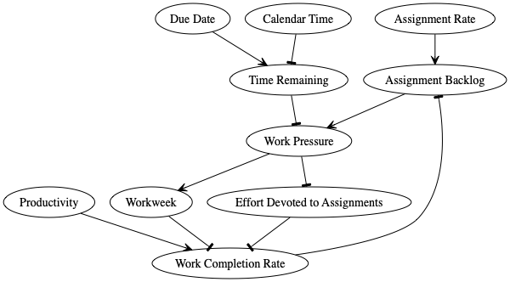

Version 2

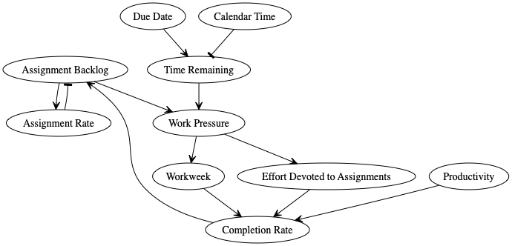

Version 3

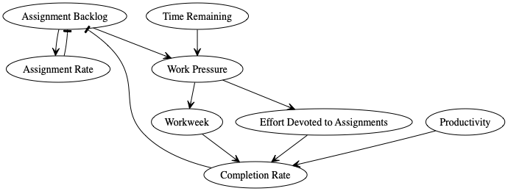

Version 4

